Screenshots of Multiple Year Stock Data Results

Tab 2014

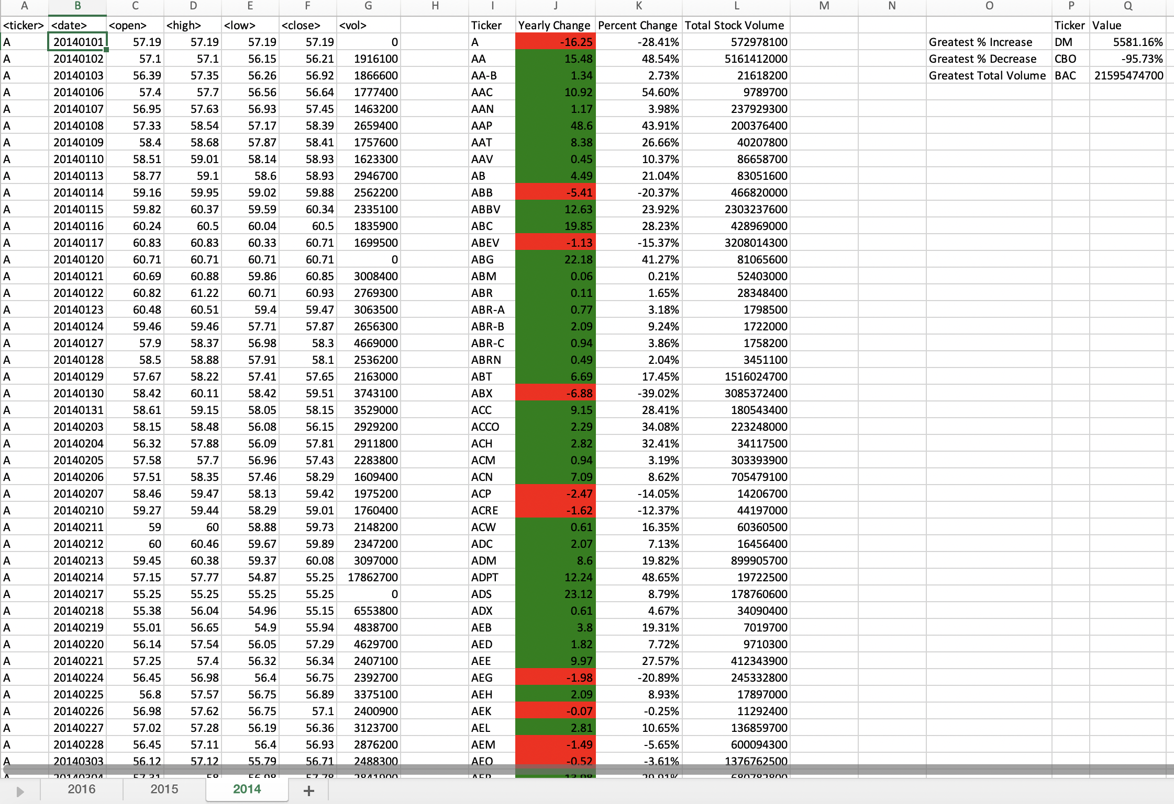

Tab 2015

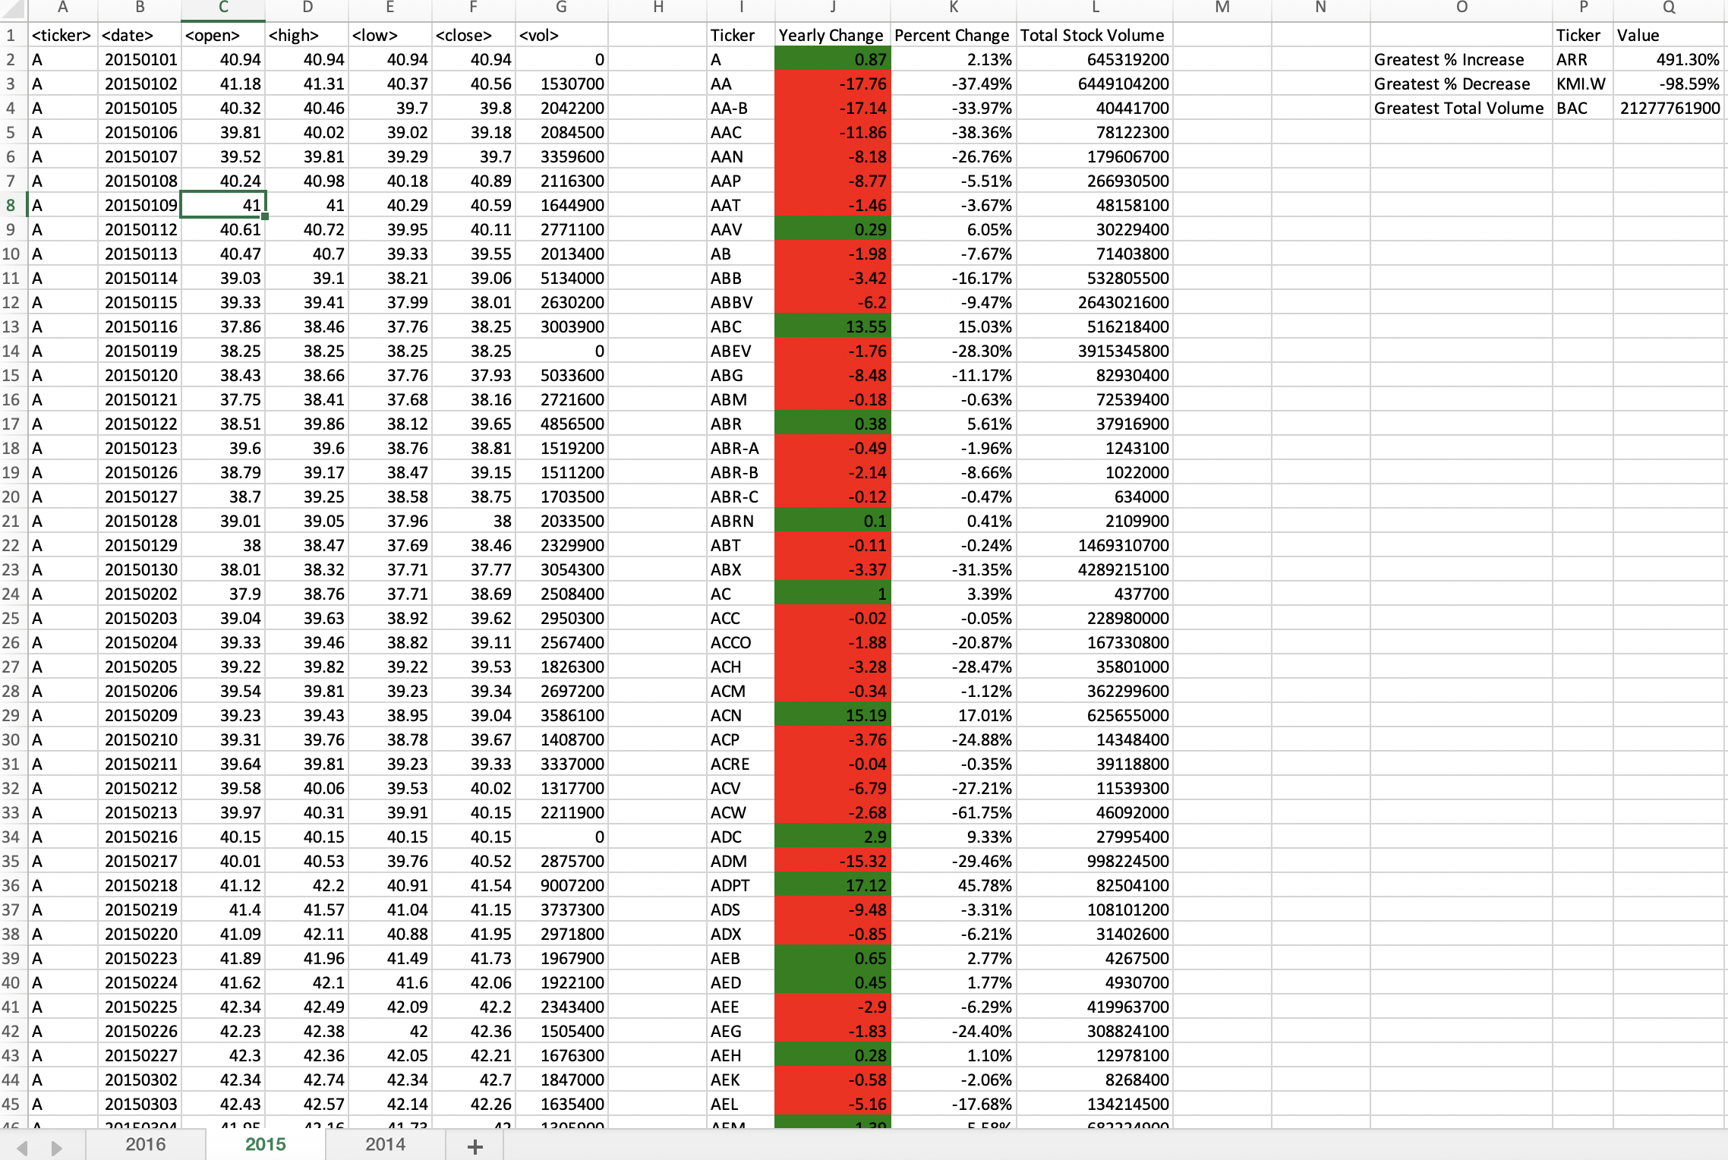

Tab 2016

